# Activity 1: List down 4 attributes a project looks for in a new hire

1.

2.

3.

4.

# Activity 2: Arrange the order of these elements in a profile

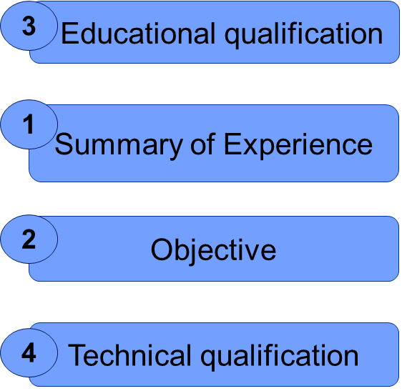

**Answer:**

# Activity 3:

|  |  |
| --- | --- |
| Prepare & Know Your Resume Well | [Prepare & Know your resume well](https://cognizant.kpoint.com/kapsule/gcc-51efa910-6153-42e4-a82e-c7ee3a8fc319/search/Interview+skills) |

Prepare your resume. Use the attached Cognizant’ standard template & video for reference.

# 

# Activity 4: SWOT

**Strengths**

**Weaknesses**

**Opportunities**

**Threats**



**Technical**



**Strengths**

**Weaknesses**

**Opportunities**

**Threats**



**Behavioral**



# Activity 5:

Now let us look at what changes you would like to make on your resume.

# Activity 6 & 7:

Write down your self-Introduction and practice. Record your introduction. Use video for reference.

|  |  |
| --- | --- |
| Introducing Yourself | [Powerful Introductions](https://cognizant.kpoint.com/kapsule/gcc-e8cd7885-7feb-4786-8539-d901728766d2/search/Interview) |

Remember keep it short – Less than 90 seconds!

**Introduction**

|  |
| --- |
| **Face to Face Interviews – TIPS** |
| * Learn all you can about the organization from their website or printed materials in Career Services. |
| * Learn about your customer/interviewer. |
| * Arrive ten minutes early. |
| * Dress professionally. |
| * Remember to bring an extra copy of your resume and a list of references. |
| * Prepare a “30 second commercial” to sell yourself to the company. |
| * Keep a writing pad / pen handy. |
| * Smile when you speak. |
|  |

# 

# Activity: 8

|  |
| --- |
| [**https://www.youtube.com/watch?v=TGqVRMOd3OI**](https://www.youtube.com/watch?v=TGqVRMOd3OI) **- Tips to Ace an Interview** |

|  |
| --- |
| **Tips for Telephonic Interview** |
| * Use Company’s preferred greetings. |
| * Identify yourself. |
| * Use the caller’s name during the conversation. |
| * Give full attention to the caller. |
| * Speak clearly and articulate well. |
| * Be sincere with your tone of voice. |
| * Avoid using slang. |
| * Remain as calm as possible during the interview. Ask for clarification if you are not sure what is being asked. |
| * End the interview with a ‘Thank You’ to the interviewer and reiterate your interest in the position. Then follow-up with a personal ‘Thank You’ note restating your interest. |
|  |

# Preparedness for an Interview – Checklist for Self

## **Quick Tips for the last minute Interviews**

* Take the name of the Interviewers and use them during the interview
* Smile, it shows through
* Build rapport through small talk, as simple as how are you today? Or hope you are having a good day etc.,
* Use verbal nods, acknowledge their queries and explain in structured points
* When in doubt, do not hesitate to paraphrase
* Do use the star technique to highlight your skills
* Do not boast yourself, but don’t undersell
* Do not be afraid of pauses in the conversation; take time to think.
* Do not monopolize the conversation, but be an active participant.
* Be an attentive listener when the interviewer is speaking.
* Approach the interview with a positive attitude and sincere interest in the company.
* Be friendly, relaxed, and most importantly be yourself.
* Let the interviewer initiate the conversation.
* Respond to questions with more than a yes or no, make sure to incorporate specific results to highlight your qualifications and accomplishments.
* Accentuate the positives, be optimistic. Do not apologize or offer excuses for shortcomings.
* Answer negative questions positively.
* Emphasize what you can do for the organization.
* Never criticize a former employer, colleague, teacher, or institution. Avoid debating the interviewer.
* Do not argue with the interviewer. Arguing with the interviewer will shorten the interview and your chances.
* Thank each interviewer and shake their hands during closure, re-instating your interest in the position.
* Send a thank you note to each of the interviewers within 24-48 hours.

## **General Don’ts**

Feedback: Write down feedback shared by your pair or your team or trainer here. Will be your areas you will prepare for your mock and final interviews.

# Mock Interviews: Few questions you would want to prepare for Mock and final interviews

## **K Point Video links for self-learning**

|  |  |
| --- | --- |
| **K Point video topics on Interview Skills** | **Link** |
| Vocabulary - Effective Leading words | <https://cognizant.kpoint.com/kapsule/gcc-c9c70d32-dc27-4d69-8ee4-60dcd73f0ad5/search/INTERVIEWS> |
| Profiling your Interviewer | <https://cognizant.kpoint.com/kapsule/gcc-76567a15-5de0-4a79-bd75-ed68f0c4ba97?vsrc=rkh> |
| Precision Questions & Answers | <https://cognizant.kpoint.com/kapsule/gcc-ea758cd8-1e58-4a21-8fb5-6eff7aaaaf50?vsrc=rkh> |
| Conclusion and Closing | <https://cognizant.kpoint.com/kapsule/gcc-a5517263-4ebb-4b6c-8191-93d4f9bbccb3/search/Interview> |
| Listening Techniques | <https://cognizant.kpoint.com/kapsule/gcc-35cd1101-11b5-4e96-9028-af5ce16a6168/search/Interview> |
| Understanding the Job Role | <https://cognizant.kpoint.com/kapsule/gcc-030b5dfb-61bf-4292-a7cd-cc6e923e631c/search/Interview> |
| The STAR Concept | <https://cognizant.kpoint.com/kapsule/gcc-86b23be6-fb3b-4709-a73f-2704a589e104/search/Interview> |
| Aligning Your Communications Style | <https://cognizant.kpoint.com/kapsule/gcc-e40740c1-d620-4b02-b64a-1e8773797442/search/Interview> |
| Comprehending Your Interviewer's Nonverbal Communication | <https://cognizant.kpoint.com/kapsule/gcc-283af4f6-1b59-4f87-be86-e995c5e9762f/t/interview-skills-comprehending-your-interviewer> |

-----------------------------------------------------------------------------------------------------------------------------------------------------Client Culture – When your interviewer is from the UK or USA – read through

# **UK Cultural Lens**

What is to be expected if you are being interviewed by a UK Client?

* Be punctual – Demonstrate an approach that you value time.
* Be non-hierarchical –Do not use ‘Sir’ or ‘Madam’.
* Be aware of small talk – Reciprocate if initiated to small talk.
* Express feelings modestly – Do not interpret the interviewer’s detached manner (as indifference. move to notes
* Respect Privacy – Do not ask any personal questions.
* Avoid hard selling – It is likely to create distrust and resistance.

# **US Cultural Lens**

* What is to be expected if you are being interviewed by a US Client?
* Be non-hierarchical – Do not use ‘Sir’ or ‘Madam’.
* Small talk – Reciprocate if initiated to small talk.
* Be punctual – Demonstrate an approach that you value time.
* Get to the point - Do not interpret a detached manner as indifference.
* Can do attitude - Demonstrate a can-do, problem solving attitude, and a willingness to innovate and take calculated risks.
* Be explicit – Be explicit and straightforward in your communication style.